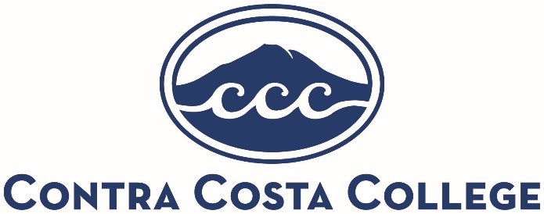
Program Review Self-Study Extension Request Form
Instructions: Complete the information below to be considered for an extension of the Program Review Self-Study deadline. The decision will be communicated with the Self-Study Team/Lead through the assigned Validation Team.
Requestor Name:____________________________________________________
Program/Department:_________________________________________________
Academic Year:______________________________________________________
Date:______________________________________________________________
Rationale. Explain why your program/department is unable to complete your Self-Study by the deadline. Provide as much information as you are able/comfortable.
___________________________________________________________________
___________________________________________________________________
___________________________________________________________________
Proposed Completion Date. When will you be able to complete the Self-Study?
___________________________________________________________________

Validation Team/Planning Committee Only Section
Validation Team recommendation (check one): Approve ____ Decline ____ Date:__________
Planning Committee Vote (check one): Approve ____ Decline ____ Date:_____________
Notes:_______________________________________________________________________
Approved New Completion Date:____________
Approved for exemption of the following consequences (check all that apply):
Program not considered for budget allocation ____
Program not considered for revitalization ____
Suspension or discontinuation of program ____

